Name : Prajakta Keer
Class : TE 10
Roll No : 33231

Problem Statement:- Creating a feedback form using JavaScript.
Complete Form :

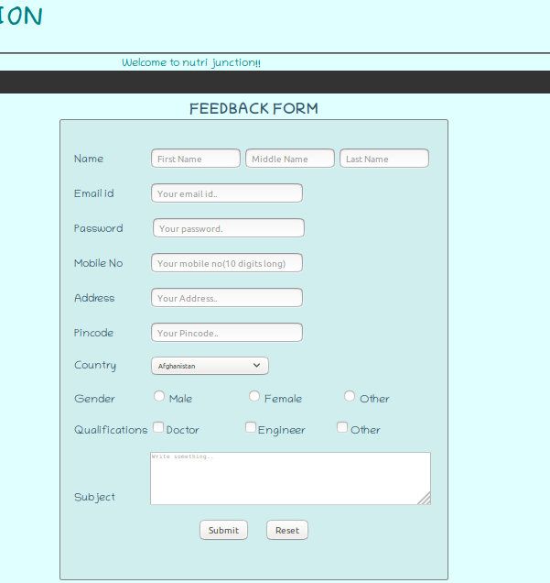
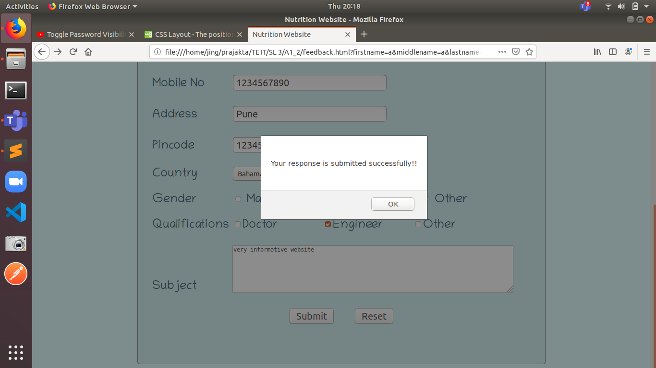
Upon Successful Submission:

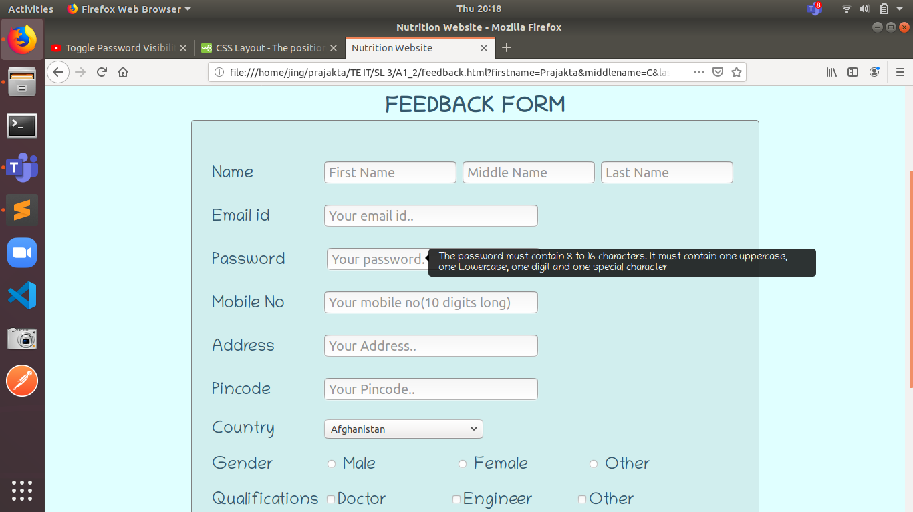
Tooltip message for password :
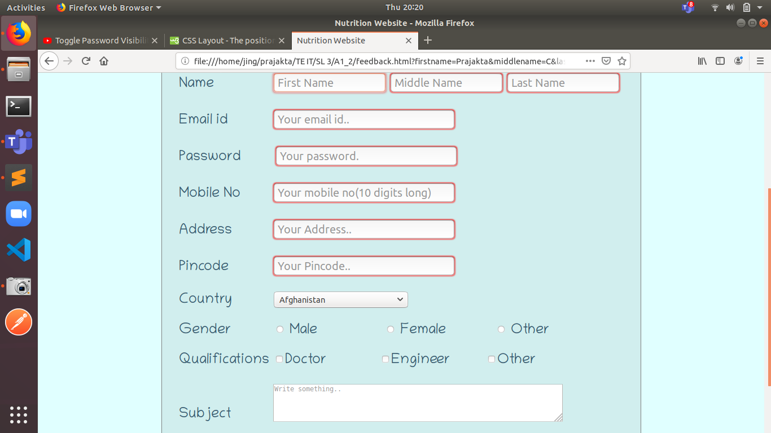
Validations for required fields :

Drop-down for country :

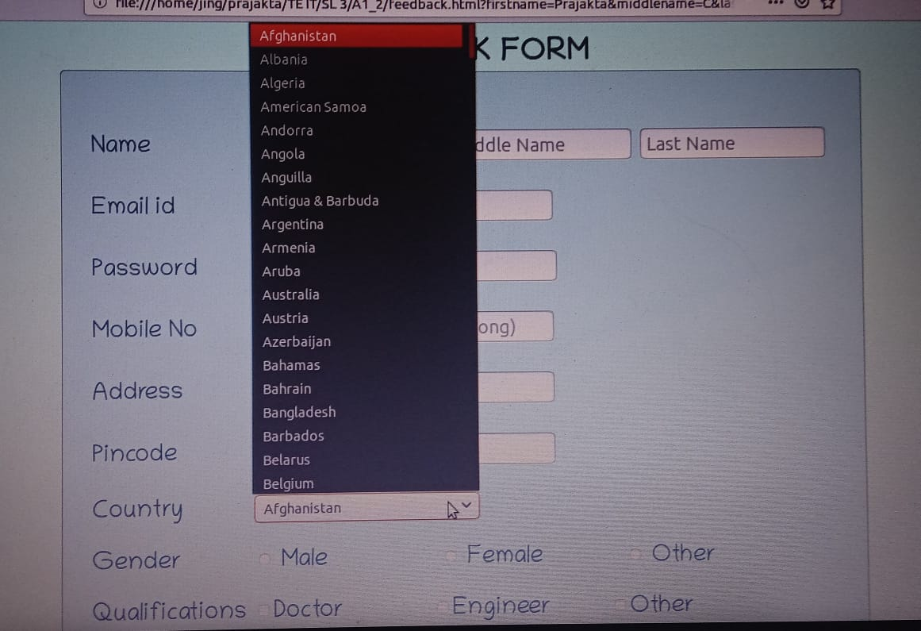
HTML CODE :
<html>

<head>
<link rel = "stylesheet" href="nutrition.css">
<title>Nutrition Website</title>
<script defer src="validations.js"></script>
</head>

<body>
<header>
<p>
<div class = "logo"><a href="nutrition.html"><img src = "logo.png"></a></div>
<div class = "title">NUTRI JUNCTION</div>
<div class = "search"><form class="example" action="action_page.php">
<!-- <input type="text" placeholder="Search.." name="search">
<button type="submit"><i class="fa fa-search"></i></button> -->
</form>
<!-- <button type="submit">Login/Register</button> -->
<!button type="submit"><!En/Hindi><!/button>
</div>
</p><br><br><br><br><br><br>
</header>
<hr>

<marquee>Welcome to nutri junction!!</marquee>

<div class="navbar">
<a href="nutrition.html">Home</a>
<div class="dropdown">
<button class="dropbtn">Topics</button>
<div class="dropdown-content">
<a href="nutrition_by_age.html">Nutrition by Age</a>
<a href="supplements.html">Supplements</a>
<a href="reciepies.html">Reciepies</a>
</div>
</div>
<a href="faq.html">FAQ's</a>
<a href="contact.html">Contact Us</a>
</div><br>

<div class = "feedback">
<center><font size = "6"><b>FEEDBACK FORM</b></font></center>

<!-- <p>Already have an account. <a href = 'login.html'>Log In</a></p></center> -->
<div class = "feedback_form">
<div class = "container">
<form name = "RegistrationForm" id = "regform" autocomplete="off">
<div class="name">
<label for = "name">Name</label>
<input type="text" id="fname" name="firstname" placeholder="First Name" maxlength="20" onkeypress="return (event.charCode > 64 && event.charCode < 91) || (event.charCode > 96 && event.charCode < 123)" required>

<!-- <label for = "mname">Middle Name</label> -->
<input type="text" id="mname" name="middlename" placeholder="Middle Name" maxlength="20" onkeypress="return (event.charCode > 64 && event.charCode < 91) || (event.charCode > 96 && event.charCode < 123)" required>

<!-- <label for = "lname">Last Name</label> -->
<input type="text" id="lname" name="lastname" placeholder="Last Name" maxlength="20" onkeypress="return (event.charCode > 64 && event.charCode < 91) || (event.charCode > 96 && event.charCode < 123)" required><br></div>

<label for = "email">Email id</label>
<input type="text" id="email" name="emailid" placeholder="Your email id.." onchange="return CheckEmail()" required><br>

<div><label for = "password">Password
<a alt="The password must contain 8 to 16 characters. It must contain one uppercase, one Lowercase, one digit and one special character" class="tooltip"> </label>
<input type="password" id="pwd" name="passwordd" placeholder="Your password." maxlength="16" minlength="8" onchange="return CheckPassword()" required></a><br>

<label for = "mobno">Mobile No</label>
<input type="text" id="mno" name="mobileno" placeholder="Your mobile no(10 digits long)" maxlength="10" onkeypress="return (event.charCode > 47 && event.charCode < 58)" minlength="10" required> <br>

<label for = "add">Address</label>
<input type="text" id="add" name="address" placeholder="Your Address.." required><br>

<label for = "pincode">Pincode</label>
<input type="text" id="pnc" name="pin" placeholder="Your Pincode.." maxlength="6" minlength="6" onkeypress="return (event.charCode > 47 && event.charCode < 58)" required> <br><br>

<label for = "cntry">Country</label>
<!-- input type="text" id="mno" name="mobileno" placeholder="Your Country."> <br>
-->
<select id="country" name="country">
<option value="Afganistan">Afghanistan</option>
<option value="Albania">Albania</option>
<option value="Algeria">Algeria</option>
<option value="American Samoa">American Samoa</option>
<option value="Andorra">Andorra</option>
<option value="Angola">Angola</option>
<option value="Anguilla">Anguilla</option>
<option value="Antigua & Barbuda">Antigua & Barbuda</option>
<option value="Argentina">Argentina</option>
<option value="Armenia">Armenia</option>
<option value="Aruba">Aruba</option>
<option value="Australia">Australia</option>
<option value="Austria">Austria</option>
<option value="Azerbaijan">Azerbaijan</option>
<option value="Bahamas">Bahamas</option>
<option value="Bahrain">Bahrain</option>
<option value="Bangladesh">Bangladesh</option>
<option value="Barbados">Barbados</option>
<option value="Belarus">Belarus</option>
<option value="Belgium">Belgium</option>
<option value="Belize">Belize</option>
<option value="Benin">Benin</option>
<option value="Bermuda">Bermuda</option>
<option value="Bhutan">Bhutan</option>
<option value="Bolivia">Bolivia</option>
<option value="Bonaire">Bonaire</option>
<option value="Bosnia & Herzegovina">Bosnia & Herzegovina</option>
<option value="Botswana">Botswana</option>
<option value="Brazil">Brazil</option>
<option value="British Indian Ocean Ter">British Indian Ocean Ter</option>
<option value="Brunei">Brunei</option>
<option value="Bulgaria">Bulgaria</option>
<option value="Burkina Faso">Burkina Faso</option>
<option value="Burundi">Burundi</option>
<option value="Cambodia">Cambodia</option>
<option value="Cameroon">Cameroon</option>
<option value="Canada">Canada</option>
<option value="Canary Islands">Canary Islands</option>
<option value="Cape Verde">Cape Verde</option>
<option value="Cayman Islands">Cayman Islands</option>
<option value="Central African Republic">Central African Republic</option>
<option value="Chad">Chad</option>
<option value="Channel Islands">Channel Islands</option>
<option value="Chile">Chile</option>
<option value="China">China</option>
<option value="Christmas Island">Christmas Island</option>
<option value="Cocos Island">Cocos Island</option>
<option value="Colombia">Colombia</option>
<option value="Comoros">Comoros</option>
<option value="Congo">Congo</option>
<option value="Cook Islands">Cook Islands</option>
<option value="Costa Rica">Costa Rica</option>
<option value="Cote DIvoire">Cote DIvoire</option>
<option value="Croatia">Croatia</option>
<option value="Cuba">Cuba</option>
<option value="Curaco">Curacao</option>
<option value="Cyprus">Cyprus</option>
<option value="Czech Republic">Czech Republic</option>
<option value="Denmark">Denmark</option>
<option value="Djibouti">Djibouti</option>
<option value="Dominica">Dominica</option>
<option value="Dominican Republic">Dominican Republic</option>
<option value="East Timor">East Timor</option>
<option value="Ecuador">Ecuador</option>
<option value="Egypt">Egypt</option>
<option value="El Salvador">El Salvador</option>
<option value="Equatorial Guinea">Equatorial Guinea</option>
<option value="Eritrea">Eritrea</option>
<option value="Estonia">Estonia</option>
<option value="Ethiopia">Ethiopia</option>
<option value="Falkland Islands">Falkland Islands</option>
<option value="Faroe Islands">Faroe Islands</option>
<option value="Fiji">Fiji</option>
<option value="Finland">Finland</option>
<option value="France">France</option>
<option value="French Guiana">French Guiana</option>
<option value="French Polynesia">French Polynesia</option>
<option value="French Southern Ter">French Southern Ter</option>
<option value="Gabon">Gabon</option>
<option value="Gambia">Gambia</option>
<option value="Georgia">Georgia</option>
<option value="Germany">Germany</option>
<option value="Ghana">Ghana</option>
<option value="Gibraltar">Gibraltar</option>
<option value="Great Britain">Great Britain</option>
<option value="Greece">Greece</option>
<option value="Greenland">Greenland</option>
<option value="Grenada">Grenada</option>
<option value="Guadeloupe">Guadeloupe</option>
<option value="Guam">Guam</option>
<option value="Guatemala">Guatemala</option>
<option value="Guinea">Guinea</option>
<option value="Guyana">Guyana</option>
<option value="Haiti">Haiti</option>
<option value="Hawaii">Hawaii</option>
<option value="Honduras">Honduras</option>
<option value="Hong Kong">Hong Kong</option>
<option value="Hungary">Hungary</option>
<option value="Iceland">Iceland</option>
<option value="Indonesia">Indonesia</option>
<option value="India">India</option>
<option value="Iran">Iran</option>
<option value="Iraq">Iraq</option>
<option value="Ireland">Ireland</option>
<option value="Isle of Man">Isle of Man</option>
<option value="Israel">Israel</option>
<option value="Italy">Italy</option>
<option value="Jamaica">Jamaica</option>
<option value="Japan">Japan</option>
<option value="Jordan">Jordan</option>
<option value="Kazakhstan">Kazakhstan</option>
<option value="Kenya">Kenya</option>
<option value="Kiribati">Kiribati</option>
<option value="Korea North">Korea North</option>
<option value="Korea Sout">Korea South</option>
<option value="Kuwait">Kuwait</option>
<option value="Kyrgyzstan">Kyrgyzstan</option>
<option value="Laos">Laos</option>
<option value="Latvia">Latvia</option>
<option value="Lebanon">Lebanon</option>
<option value="Lesotho">Lesotho</option>
<option value="Liberia">Liberia</option>
<option value="Libya">Libya</option>
<option value="Liechtenstein">Liechtenstein</option>
<option value="Lithuania">Lithuania</option>
<option value="Luxembourg">Luxembourg</option>
<option value="Macau">Macau</option>
<option value="Macedonia">Macedonia</option>
<option value="Madagascar">Madagascar</option>
<option value="Malaysia">Malaysia</option>
<option value="Malawi">Malawi</option>
<option value="Maldives">Maldives</option>
<option value="Mali">Mali</option>
<option value="Malta">Malta</option>
<option value="Marshall Islands">Marshall Islands</option>
<option value="Martinique">Martinique</option>
<option value="Mauritania">Mauritania</option>
<option value="Mauritius">Mauritius</option>
<option value="Mayotte">Mayotte</option>
<option value="Mexico">Mexico</option>
<option value="Midway Islands">Midway Islands</option>
<option value="Moldova">Moldova</option>
<option value="Monaco">Monaco</option>
<option value="Mongolia">Mongolia</option>
<option value="Montserrat">Montserrat</option>
<option value="Morocco">Morocco</option>
<option value="Mozambique">Mozambique</option>
<option value="Myanmar">Myanmar</option>
<option value="Nambia">Nambia</option>
<option value="Nauru">Nauru</option>
<option value="Nepal">Nepal</option>
<option value="Netherland Antilles">Netherland Antilles</option>
<option value="Netherlands">Netherlands (Holland, Europe)</option>
<option value="Nevis">Nevis</option>
<option value="New Caledonia">New Caledonia</option>
<option value="New Zealand">New Zealand</option>
<option value="Nicaragua">Nicaragua</option>
<option value="Niger">Niger</option>
<option value="Nigeria">Nigeria</option>
<option value="Niue">Niue</option>
<option value="Norfolk Island">Norfolk Island</option>
<option value="Norway">Norway</option>
<option value="Oman">Oman</option>
<option value="Pakistan">Pakistan</option>
<option value="Palau Island">Palau Island</option>
<option value="Palestine">Palestine</option>
<option value="Panama">Panama</option>
<option value="Papua New Guinea">Papua New Guinea</option>
<option value="Paraguay">Paraguay</option>
<option value="Peru">Peru</option>
<option value="Phillipines">Philippines</option>
<option value="Pitcairn Island">Pitcairn Island</option>
<option value="Poland">Poland</option>
<option value="Portugal">Portugal</option>
<option value="Puerto Rico">Puerto Rico</option>
<option value="Qatar">Qatar</option>
<option value="Republic of Montenegro">Republic of Montenegro</option>
<option value="Republic of Serbia">Republic of Serbia</option>
<option value="Reunion">Reunion</option>
<option value="Romania">Romania</option>
<option value="Russia">Russia</option>
<option value="Rwanda">Rwanda</option>
<option value="St Barthelemy">St Barthelemy</option>
<option value="St Eustatius">St Eustatius</option>
<option value="St Helena">St Helena</option>
<option value="St Kitts-Nevis">St Kitts-Nevis</option>
<option value="St Lucia">St Lucia</option>
<option value="St Maarten">St Maarten</option>
<option value="St Pierre & Miquelon">St Pierre & Miquelon</option>
<option value="St Vincent & Grenadines">St Vincent & Grenadines</option>
<option value="Saipan">Saipan</option>
<option value="Samoa">Samoa</option>
<option value="Samoa American">Samoa American</option>
<option value="San Marino">San Marino</option>
<option value="Sao Tome & Principe">Sao Tome & Principe</option>
<option value="Saudi Arabia">Saudi Arabia</option>
<option value="Senegal">Senegal</option>
<option value="Seychelles">Seychelles</option>
<option value="Sierra Leone">Sierra Leone</option>
<option value="Singapore">Singapore</option>
<option value="Slovakia">Slovakia</option>
<option value="Slovenia">Slovenia</option>
<option value="Solomon Islands">Solomon Islands</option>
<option value="Somalia">Somalia</option>
<option value="South Africa">South Africa</option>
<option value="Spain">Spain</option>
<option value="Sri Lanka">Sri Lanka</option>
<option value="Sudan">Sudan</option>
<option value="Suriname">Suriname</option>
<option value="Swaziland">Swaziland</option>
<option value="Sweden">Sweden</option>
<option value="Switzerland">Switzerland</option>
<option value="Syria">Syria</option>
<option value="Tahiti">Tahiti</option>
<option value="Taiwan">Taiwan</option>
<option value="Tajikistan">Tajikistan</option>
<option value="Tanzania">Tanzania</option>
<option value="Thailand">Thailand</option>
<option value="Togo">Togo</option>
<option value="Tokelau">Tokelau</option>
<option value="Tonga">Tonga</option>
<option value="Trinidad & Tobago">Trinidad & Tobago</option>
<option value="Tunisia">Tunisia</option>
<option value="Turkey">Turkey</option>
<option value="Turkmenistan">Turkmenistan</option>
<option value="Turks & Caicos Is">Turks & Caicos Is</option>
<option value="Tuvalu">Tuvalu</option>
<option value="Uganda">Uganda</option>
<option value="United Kingdom">United Kingdom</option>
<option value="Ukraine">Ukraine</option>
<option value="United Arab Erimates">United Arab Emirates</option>
<option value="United States of America">United States of America</option>
<option value="Uraguay">Uruguay</option>
<option value="Uzbekistan">Uzbekistan</option>
<option value="Vanuatu">Vanuatu</option>
<option value="Vatican City State">Vatican City State</option>
<option value="Venezuela">Venezuela</option>
<option value="Vietnam">Vietnam</option>
<option value="Virgin Islands (Brit)">Virgin Islands (Brit)</option>
<option value="Virgin Islands (USA)">Virgin Islands (USA)</option>
<option value="Wake Island">Wake Island</option>
<option value="Wallis & Futana Is">Wallis & Futana Is</option>
<option value="Yemen">Yemen</option>
<option value="Zaire">Zaire</option>
<option value="Zambia">Zambia</option>
<option value="Zimbabwe">Zimbabwe</option>
</select><br>

<label for = "gd">Gender</label>
<input type="radio" id="male" name="gender">
<label for = "gender">Male</label>
<input type="radio" id="female" name="gender">
<label for = "gender">Female</label>
<input type="radio" id="other" name="gender">
<label for = "gender">Other</label> <br>

<label for = "quals">Qualifications</label>
<input type="checkbox" id="qual" name="Qualifications"><label>Doctor</label>
<input type="checkbox" id="qual" name="Qualifications"><label>Engineer</label>
<input type="checkbox" id="qual" name="Qualifications"><label>Other</label><br><br>

<label for="subject">Subject</label>
<textarea id="subject" name="subject" placeholder="Write something.." style=" height:150px; width:350px"></textarea><br>

<!-- https://www.w3schools.com/html/html_form_input_types.asp -->
<center><button class = "btn" onclick = "return validateBlanks()">Submit</button><!-- <input type="submit" value="Register"> -->&nbsp;&nbsp;&nbsp;&nbsp;&nbsp;&nbsp;<input type="reset" value="Reset"></center><br>

</div>
</form>
</div>

</center>
</div>

</body>
</html>

CSS CODE :

.feedback {
font-family: Chilanka;
font-size : 20px;
color:#35586C;
}

.feedback_form {
font-family: Chilanka;
font-size : 25px;
box-sizing: border-box;
border-radius: 5px;
background-color: #D1EEEE;
padding: 30px;
margin: 0 auto;
width: 850px;
border: 1px solid transparent;
border-color:grey;
/*height:520px;*/
}

.feedback_form input {
font-size:20px;
margin-top : 30px;
/*width: 200px;*/
}

.name input {
width: 200px;
}

/*.feedback_form input:invalid {
border: 2px red;
border-radius: 5px;
}

.feedback_form input:valid {
/* border: 2px solid black;
*/ /*border-radius: 5px;
}*/

.tooltip
{
display: inline;
position: relative;
text-decoration: none;
top: 0px;
left: 4px;
}
.tooltip:hover:after
{
background: #333;
background: rgba(0,0,0,.8);
border-radius: 5px;
top: -5px;
color: #fff;
content: attr(alt);
left: 160px;
padding: 5px 15px;
position: absolute;
z-index: 98;
width: 550px;
font-size: 15px;
}
.tooltip:hover:before
{
border: solid;
border-color: transparent black;
border-width: 6px 6px 6px 0;
bottom: 20px;
content: "";
left: 155px;
position: absolute;
z-index: 99;
top: 3px;
}

.container label {
display: inline-block;
width : 160px;
}

.btn {
font-size: 20px;
}

Javascript Code :

function validateBlanks() {

if(CheckRadio() && CheckQualification()) {
alert("Your response is submitted successfully!!");
return true;
}
}

function CheckEmail() {
var mailformat = /^[a-zA-Z0-9.!#$%&'*+/=?^_`{|}~-]+@[a-zA-Z0-9-]+(?:\.[a-zA-Z0-9-]+)*$/;
var eid = document.RegistrationForm.emailid;
if(eid.value.match(mailformat)) {
/*alert("Valid email address!");
document.form1.text1.focus();*/
return true;
}
else {
//alert("You have entered an invalid email address!");
document.getElementById("email").focus();
return false;
}
}

function CheckPassword() {
var decimal= /^(?=.*\d)(?=.*[a-z])(?=.*[A-Z])(?=.*[^a-zA-Z0-9])(?!.*\s).{8,16}$/;
var pwd = document.RegistrationForm.passwordd;
if(pwd.value.match(decimal))
{
return true;
}
else
{
//alert('Password must be 8 to 16 characters long and must contain one lowercase, one upercase, one digit and one special symbol.')
return false;
}
}

function CheckRadio() {
var genders = document.getElementsByName("gender");
if (!(genders[0].checked || genders[1].checked || genders[2].checked)) {
alert("Please Select Your Gender");
return false;
}
else {
return true;
}
}

function CheckQualification() {
var qual = document.getElementsByName("Qualifications");
if (qual[0].checked == false && qual[1].checked == false && qual[2].checked == false) {
alert("Please Select Your Qualifications");
return false;
}
else {
return true;
}
}

References :

https://www.w3schools.com/

https://medium.com/@naveenkarippai/learning-how-references-work-in-javascript-a066a4e15600

https://daveceddia.com/javascript-references/

